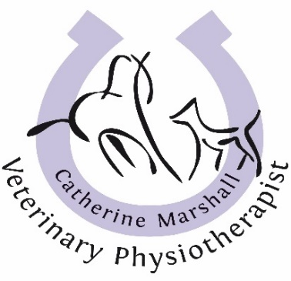
GDPR Policy Statement
CM Vet Physio is fully GDPR (The General Data Protection Regulation) compliant.
The Personal Data I collect will include your name, address, telephone and e-mail, data relating to your animal’s health and your referring Veterinary Surgeon.
These Details will not be shared or sold to any organisations or third party, or used maliciously in any way.
To comply with the RCVS (Royal College of Veterinary Surgeons) Act, treatment records will be shared with your referring Veterinary Practice and may be required by your insurance company when dealing with claims for treatment.
Any information, photos or videos of your animal will be digitally stored on password protected devices and your consent will be obtained before any images or treatment information is shared on social media.
All written data is stored in a locked cabinet.
Your data will be used to manage future communications between CM Vet Physio and yourself, including future appointments and my products and services, emails of offers, courses and newsletters.
Please tick your preferred methods of communications.
Telephone □ Text Message □
E-Mail □ Facebook □
You can opt out of any communication method at any time by emailing enquiries@cmvetphysio.co.uk
I operate within an ethical code of practice and you are welcome to view your animal’s records at any time. Treatment records will be kept on file for a period of 7 years after the last treatment was administered, to ensure compliance with the UK’s Statue of Limitation.
I am happy for any photos/videos taken of my pet to be shared on social medial after verbal discussion. □
My pet is insured and I am happy for my information to be shared with my insurance company in relation to a claim. □
Signed...…………………………………………………………………… Date………………………

